Software Requirements Specification   
Online Examination System

Author(s): SHARMILA S

Date: April 3, 2024

1. Objective and Scope 3

2. Project End Users 3

3. Features 4

3.1 User Authentication 3

3.2 Question Presentation 3

3.3 Question Bank Management 4

3.4 Scoring and Grading 4

3.5 Result Analysis 4

4. Functional Requirements 3

5. Non-Functional Requirements 3

6. Flowchart 6

7. Class Diagram 6

8. Sequence Diagram 7

9. ER Diagram 7

# Objective and Scope

The scope and objective of a school management system are to build a system where exams can be taken online easily. It will help schools and companies conduct tests without hassle, making sure everything is secure and convenient for everyone involved.

The scope of the product includes the following basic features:

* User-friendly interface for both exam administrators and test-takers.
* Secure login and authentication system to ensure the integrity of exams.
* Ability to create, edit, and manage different types of exams with customizable settings.
* Automatic grading and result generation to save time and effort.
* Accessible anytime, anywhere, allowing for remote exam administration and participation.

# Project End Users

1. Students, who take exams online from various educational institutions.

2. Teachers and administrators, who create, manage, and assess exams within their respective institutions.

# Features

## User Authentication:

* Secure login system requiring username and password.
* Authentication mechanism to ensure only authorized users can access the system.

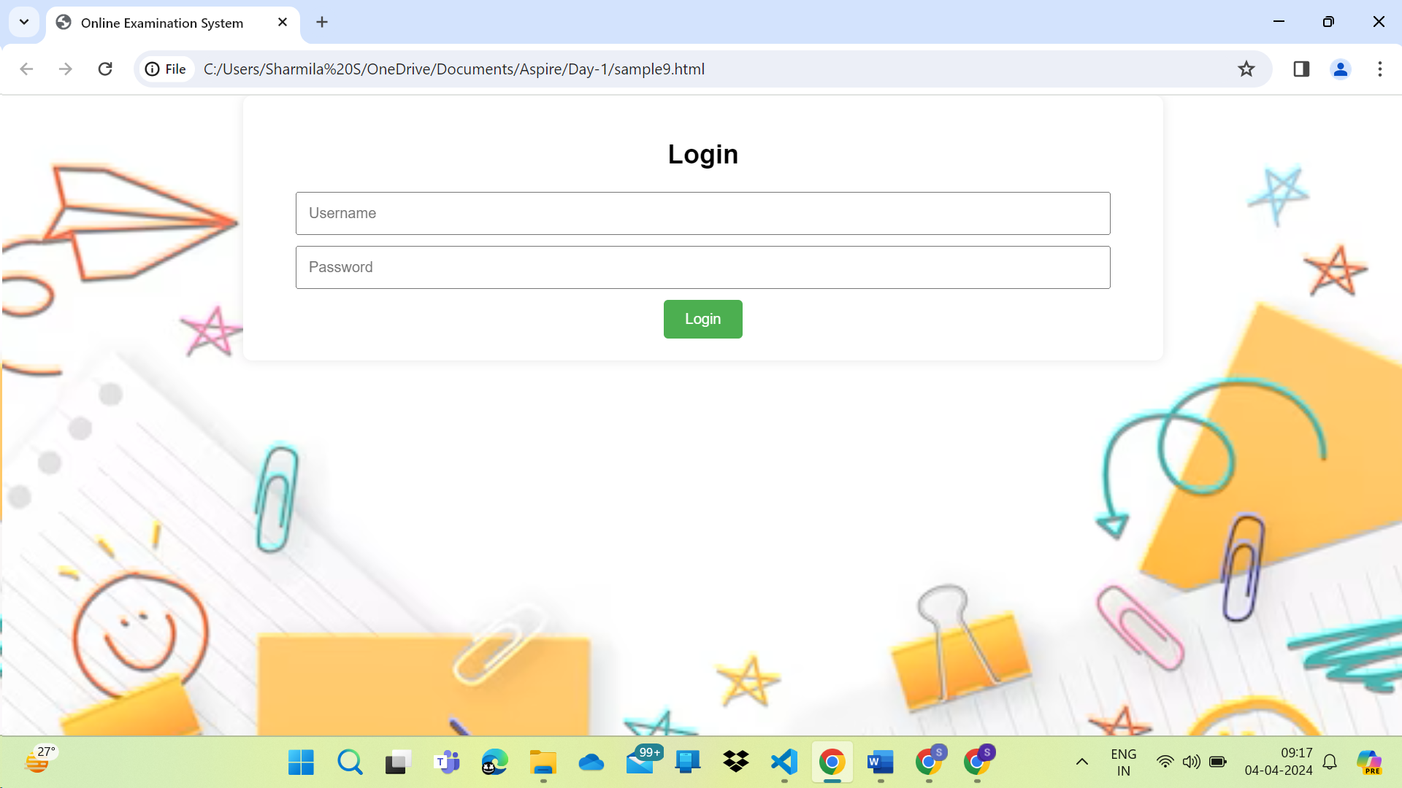

## Question Presentation:

* Structured display of examination questions.
* Each question accompanied by multiple-choice options.
* Questions categorized into sections for better organization.

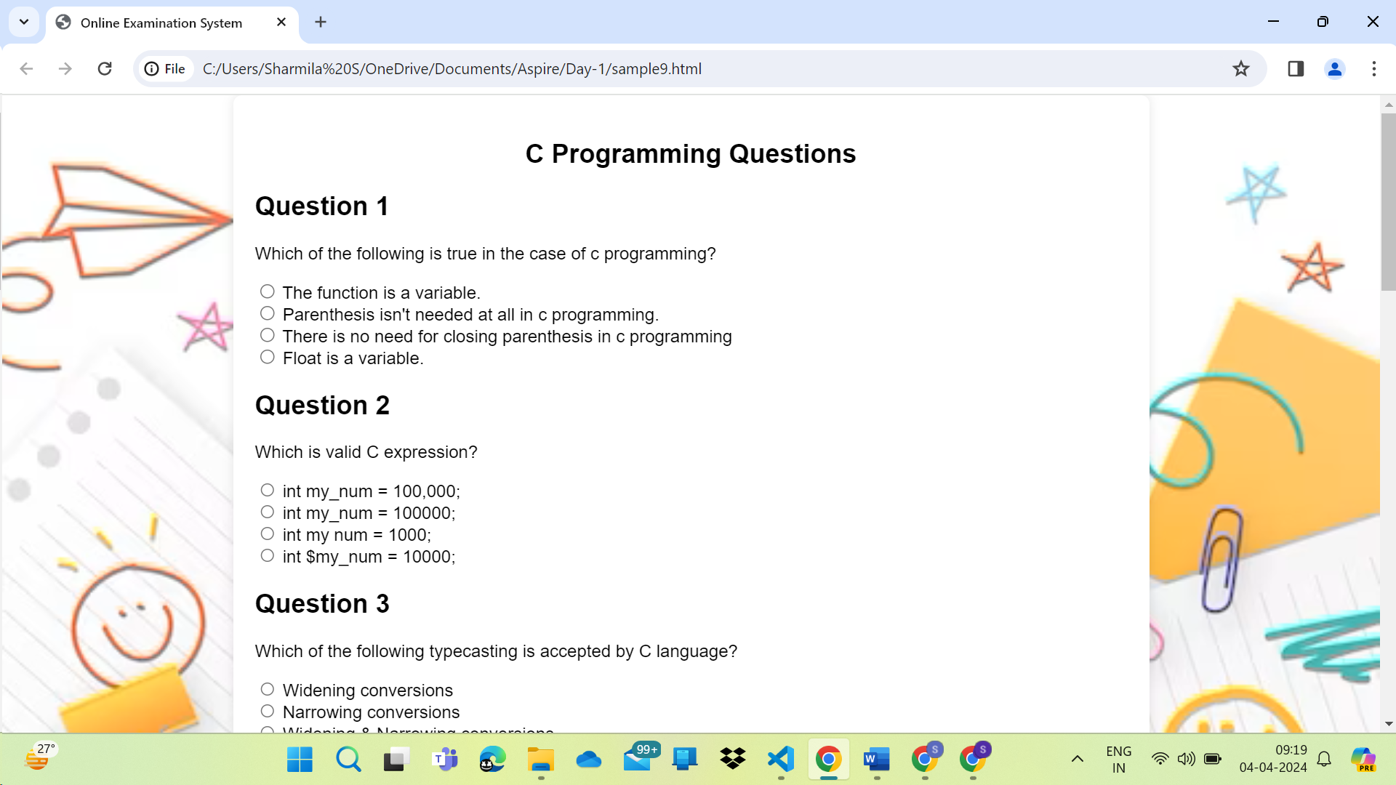

## Question Bank Management:

* Ability to add, edit, or remove questions from the question bank.
* Support for various question formats such as multiple choice, true/false, and short answer.

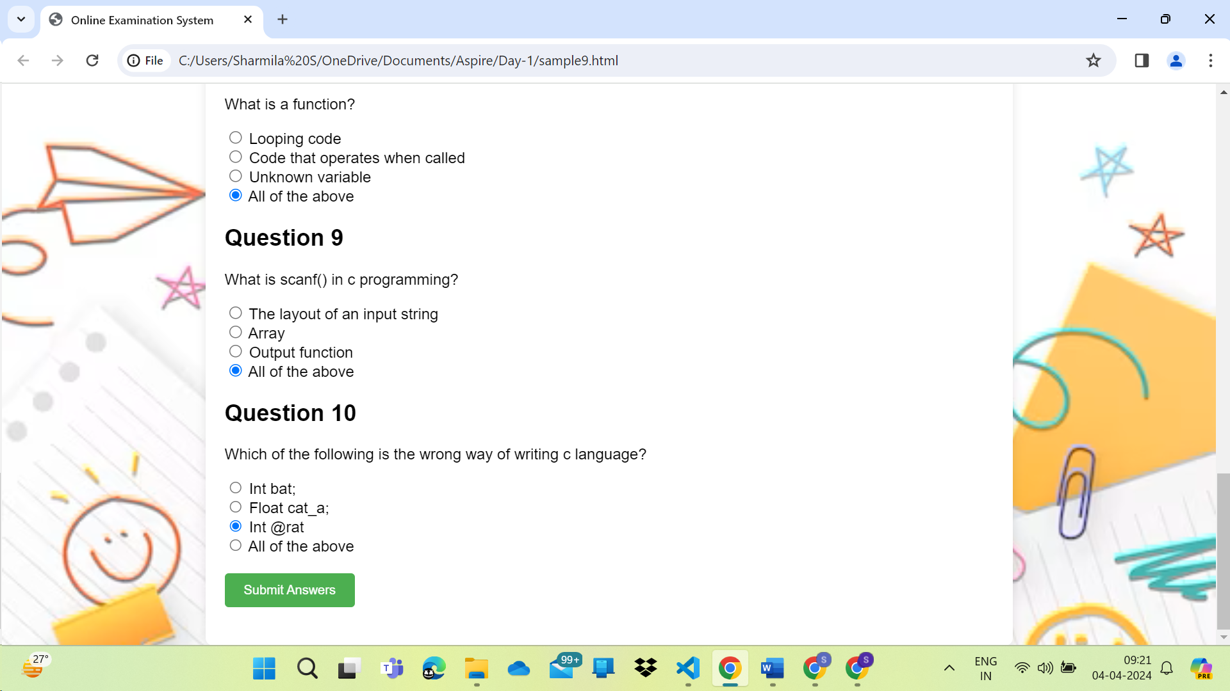

## Scoring and Grading:

* Automatic scoring of exams based on predefined correct answers.
* Calculation of grades or marks obtained by the examinee.

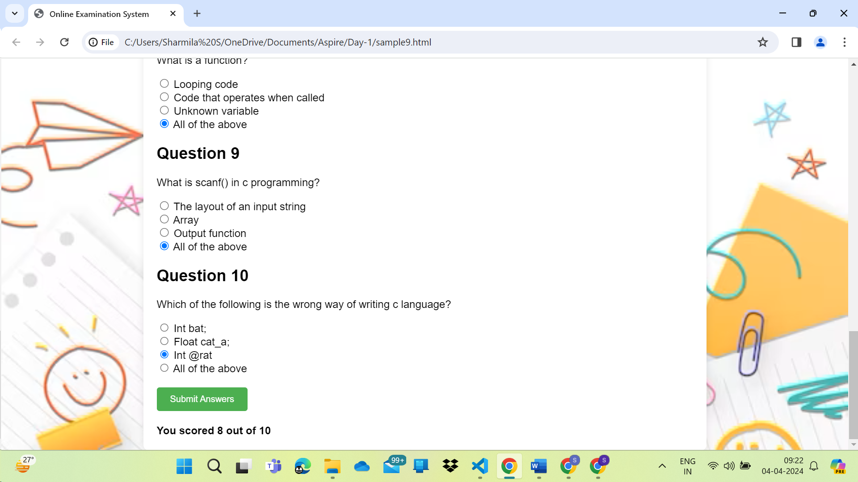

## Result Analysis:

* Detailed analysis of exam results, including overall performance and individual question analysis.
* Graphical representation of results for easy interpretation.

# Functional Requirements:

**User Authentication:** Users should be able to log in securely with unique credentials.

**Question Management:** Ability to create, edit, and delete exam questions.

**Exam Configuration:** Option to set time limits, randomize questions, and specify passing criteria.

**Exam Taking:** Users should be able to take exams online, with features like question navigation, saving answers, and submitting exams.

**Scoring:** Automatically evaluate exam submissions and provide scores to users.

**Result Management:** Display exam results to users and administrators.

# Non-Functional Requirements:

**Security:** Ensure data encryption, prevent unauthorized access, and protect against cheating.

**Performance:** System should handle multiple users concurrently without slowdowns or crashes.

**Reliability:** System should be available whenever needed and maintain data integrity.

**Usability:** Intuitive user interface with clear instructions for easy navigation.

**Scalability:** Ability to handle increasing number of users and exams without significant changes.

**Accessibility:** Ensure the system is accessible to users with disabilities, following WCAG guidelines.

**Compatibility:** Support multiple devices and browsers to accommodate diverse user base.

# Flowchart:

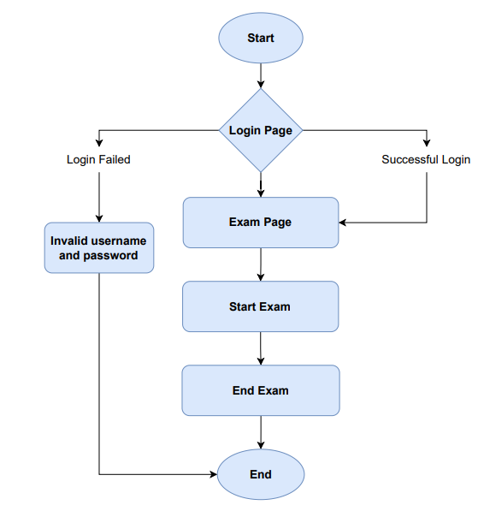

# Class Diagram:

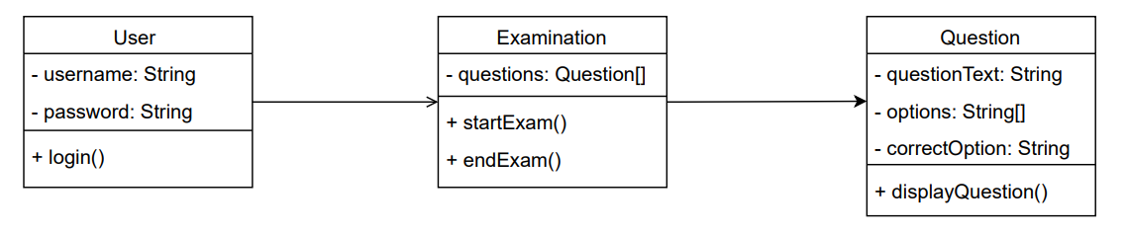

# Sequence Diagram:

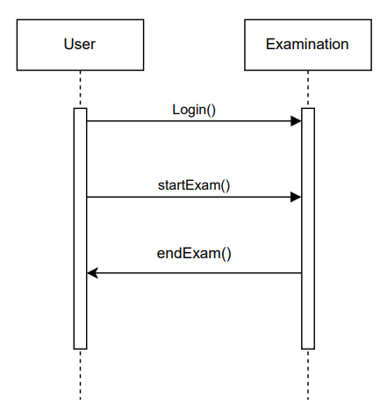

# ER Diagram:

